Multimedia Revision github/Ahmedkhalil777

https://github/AhmedKhalil777

**In The Name Of ALLAH**

# Module 1 (Intro to Multimedia)

* Every One has a different **Viewpoint** for “Multimedia” Word:
  + **PC Vendor**: as a collection of **HW** devices (Sound Capability - DVD Rom – and Perhaps understand that they have Microprocessor Capabilities)
  + **Consumer for Entertainment**: as a **TV** with hundreds of Channels
  + **CS Student**: ***Application*** that use multiple **modalities (Images , Text , animation , Video , interactivity)**

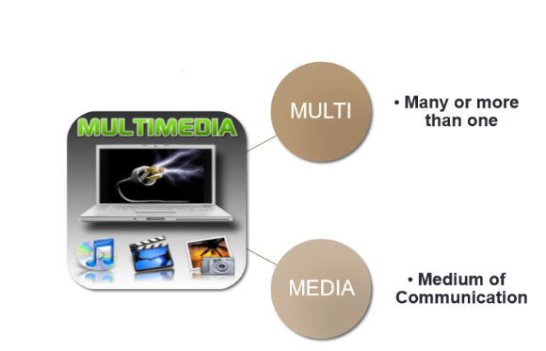**Multi (multus)** : “**numerous, multiple**”

**Media (medium)**: “**middle, center**” (hardware + software) used for **dissemination** (distribute) and **representation of information**

usage of multiple **agents (text, audio, video, images)** for disseminating and presenting information to audience

**simultaneous use of more than one medium**

**better name is "Integrated media".**

## Multimedia Consists of

**all applications** that involve a combined use of **different kinds of media**

* The Presentation that use them Called => **Multimedia Presentation**
* The Software also use them => **Multimedia Software**
* System ….. => **Multimedia System**

**Multimedia Application** is an application which uses a collection of multiple media sources like (— World Wide Web, — Multimedia Authoring, e.g. Adobe/Macromedia Director, — Video-on-demand, — Interactive TV, — Computer Games, — Digital video editing and production systems, — Multimedia Database systems.)

* **Business: (Sales / Marketing Presentation ▪ Trade show production ▪ Staff Training Application ▪ Company Kiosk)**
* **Education: (Courseware / Simulations E-Learning / Distance Learning , Information Searching)**
* **Entertainment: (Games (Leisure / Educational) , Movies , Video on Demand)**
* **Public places: Information Kiosk , Smart Cards, Security**
* **Home : Television Satellite TV , SMS services (chats, voting, reality TV)**

**Multimedia System:** A system that involves generation, representation, storage, transmission, search and retrieval, and delivery of multimedia information => 3 Processes inherent to these systems:

* 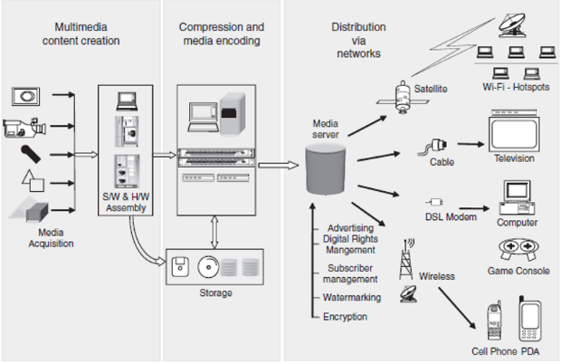**Multimedia content creation or multimedia authoring:** digitizing media
  + variety of different instruments, which capture different media types in a digital format.
* **Storage and compression:** minimize necessities for storage and distribution
* **Distribution :** distribution across a variety of low bandwidth and high-bandwidth networks.
  + Distribution normally follows **standards protocols**, which are responsible for **collating and reliably** sending information to end receivers.

## Inherent Qualities of Multimedia Data

* **Digital**: digital nature allows it to be combined together to produce rich content.
* **Voluminous**: **size** of the data resulting from combining these medias is **Large** and **Voluminous** => we need **compression techniques => Care of** storage and transmission bandwidth limitations
* **Interactive:** many options to do with the same multimedia e.g you can click on areas of an image causing an action to be taken, Web site consisting of hyperlinked text**.**
* **Real-time and synchronization:** need much transmission speed Real-time => can be only **a very small** and bounded delay while transmitting information

## Different Media Types Used Today

* Text:
  + commonly used to express information
  + text information has evolved from simple text to more meaningful and easy-to-read **formatted text**
  + **hypertext** is commonly used in digital documents, allowing **nonlinear access to information**.
  + **Linear multimedia:** active content progresses without any navigation control for the viewer such as a cinema presentation or movie.
  + **Non-linear multimedia**: user interactivity, such as selection buttons or hyperlinks, to control progress as used with a computer game or used in self-paced computer-based training.
  + Non-linear content is also known as hypermedia content.
* Image:
  + consist of a set of units called pixels => 2 dimensional array (Width - Height) => the same bit depth for each pixel in the same image.
  + **Bit depth** : number of bits assigned to each pixel. => control the level of colors and types (monochrome , intensity , color image , indexed images)
  + **Size = Width * Height * Bit Depth.**
  + **Formats :** application-specific (jpeg , png , faxes , …………)
  + **Dimensionality:** singularly or combined => just an image or stereo image (Panoramas)
* Video**:** 
  + represented as a sequence of images
  + Width , Height , Pixel Depth , frames per second or fps.
  + **Size = W * H * pixel Depth * frames per second * duration of video**
  + **Aspect ratio:** The ratio of the Width: Height=> common aspect ratio for video is 4:3, High Definition 16:9
  + 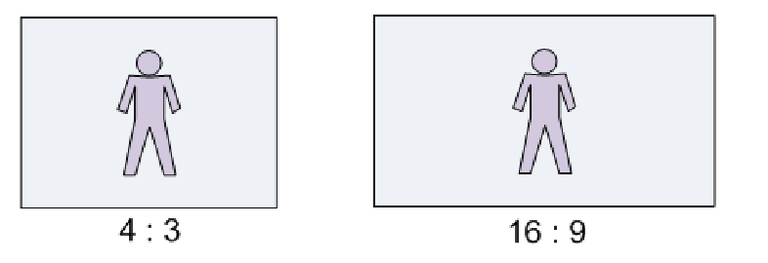
  + **Scanning format:** convert the frames of video into a one-dimensional signal for broadcast.
    - **Interlaced scanning:** Scanning odd rows then even’s , Flickers problem **(The Middle of Last Century 1950’s)**
    - **progressive scanning:** all rows scanned on one frame, Better quality
    - 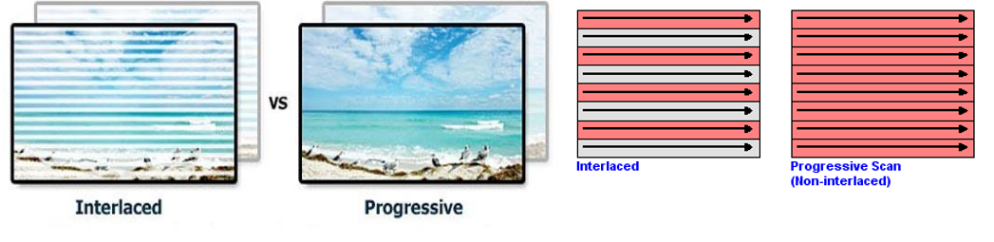
* 2D Graphics:
  + commonplace in multimedia presentations
  + represented by **2D vector** coordinates and normally has properties such as a fill color, boundary thickness, and so on.
  + effectively used to create 2D animations **to better illustrate information**.
* 3D Graphics:
  + used today for **high-end content** in movies, computer games, and advertising.
  + have advanced considerably as a science

## Table 1.1 Classification of Multimedia Systems

|  |  |
| --- | --- |
| Static | * multimedia data remains the same within a certain finite time * slide of a Microsoft PowerPoint presentation or one HTML Web page. |
| Dynamic | * data is changing like watching a video |
| Real-time | * Playing online shooting games Pubg , Watching Youtube |
| orchestrated | * refers to cases when there is no real-time requirement. * compressing content on a DVD and distributing it. Common for download the media |
| Linear | * proceed **linearly** through the information * reading an eBook or watching a video. |
| Non-Linear | * make **use of links** that map one part of the data to another. * The term hypermedia generalizes the concept of accessing media nonlinearly. |
| Person-to-machine vs person-to-person | the end user is interacting with a machine or with another person. |
| Single user, peer-to-peer, peer-to-multipeer, and broadcast | * Just me , Unicast , Multicast , Broadcast * the manner of information distribution. * **Broadcasting** is the most **general-purpose scenario**, where information is sent not to any specific listener(s) but available to all those who want to listen, such as television and radio broadcasts. |



# Module 2 “Digital Data Acquisition”

* **Digitizing process(analog-to Digital process)**: Convert the analog signals to digital signals
* This process for recording of information into a digital medium to ease filtration, compression, and distribution.
* physical world around us exists in a continuous form(light, sound energy, pressure, temperature, motion)
* **Recording instruments**: such as cameras, camcorders, microphones, gauges, and so on, attempt to **measure information** in an electrical and digital form.
  + **digital camera** contains => CCD (Coupled charged Device) array of sensors that release an electric charge that is proportional to the amount of light energy falling on it. (the more energy, the higher the charge)
* **Quality and the Quantity:** are important to the creation and distribution of multimedia
  + More Quantity seems you need much Bandwidth and storage and but generate more Quality

## We digitized the media as

* 1-dimansional => audio (amplitudes)
* 2-dimansional => image (width and height)
* 3-dimansional => videos (Frames dimensions and the (width and height))

## Analog and Digital Signals

* **Analog signals** are captured by a recording device => as a Physical Signal represented by a continuous function
  + encode the changing amplitude with respect to an input dimension(s)
* **Digital signals** are represented by a discrete set of values defined at specific instances of the input domain, which might be time, space, or both.

## Advantages of Digital Signals over Analog one

* We can create complex, interactive content from digital signal.
* In the digital medium, we can access each unit of information for a media type.
  + access a pixel in an image, or a group of pixels
  + Different digital operations can be applied => enhance the image quality of a region or remove noise in a sound track.
  + combined or composited to create richer content, which is not easy in the analog medium.
* Stored digital signals do not degrade over time
  + Drawbacks of analog storing is **Ghosting** in VHS tapes => repeated usage and degradation of the medium over time.
* Digital data can be efficiently **compressed and transmitted** across digital networks.
* easy to store digital data on magnetic media (portable 3.5 inch, hard drives, or solid state memory devices)

***digital data*** is preferred because it offers **better quality** and **higher fidelity**, can be easily used to create **compelling content**, and can also be **compressed, distributed, stored, and retrieved relatively** easily.

## Analog to digital conversion

1. First must convert from Analog to Digital Signal may be stored or transmitted may be altered through digital signal processing(filtered or have effects applied).
   1. Audio data compression techniques (MP3, or Advanced Audio Coding) to reduce the file size =>Digital audio can be streamed to other devices.
2. converted back to an analog signal with a DAC.

* Computers work with **discrete pieces** of information
* The conversion of signals from **analog to digital** occurs
  + Sampling
  + Quantization
* **Interpolation : The Reverse operation (Digital to Analog Converting)**
* 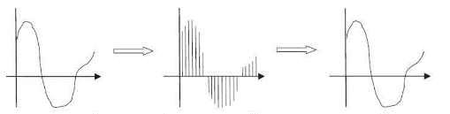ensure that no artifacts are created in the digital data is desirable property.
  + converted back to the analog domain, it will look the same as the original analog signal.
* To convert an image to digital form, we have to sample the function in both coordinates and in amplitude.
  + 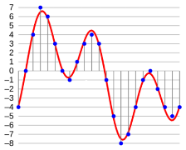**Sampling**: Digitizing the coordinate values
  + **Quantization**: Digitizing the amplitude values
* **sampling** is done across
  + one dimension (time, for sound signals)
  + two dimensions (spatial x and y, for images)
  + three dimensions (x, y, time for video).
  + one-dimensional analog signal in the time 𝑡 domain, with an amplitude given by 𝑥(𝑡).where 𝑇 is the time interval between samples , 𝑓 is sampling rate = no of samples per second
  + **reduce 𝑇** (**increase 𝑓** ) vice versa.
  + 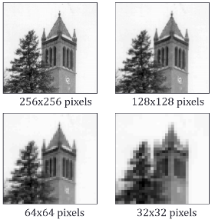If T is too large, the signal might be under sampled, leading to artifacts
    - Lower sampling rate, allow less quality, less information and we will use less storage space and transmission will be faster.
  + If T is too small, the signal requires large amounts of storage, which might be redundant.
    - Higher sampling rates allow the image to be more accurately represented and more storage.
* **Quantization:** encoding the **signal value** at every **sampled location** with a **predefined precision**, defined by a **number of levels**.
  + 𝑥𝑞(𝑛) = 𝑄[𝑥𝑠(𝑛)]
    - 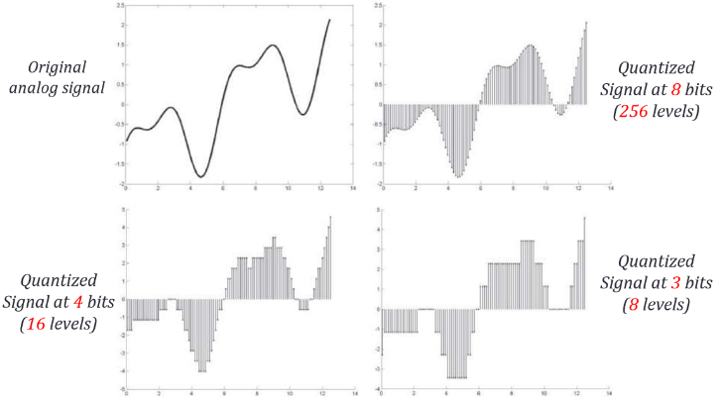**𝑄** represents a **rounding function** that maps the **continuous value** 𝑥𝑠(𝑛) to the nearest digital value using 𝑏 bits.
    - **Levels N = 2b**
    - entire range (𝑅)
    - quantization step 𝑑𝑒𝑙𝑡𝑎 = 𝑅 /2𝑏.
  + quantization of a sample value is dependent on the **number of bits** used to represent the **amplitude**
  + The greater the number of bits used, the better the resolution, but the more storage space is required.
  + Quantization - divide the vertical axis (amplitude) **into pieces**.
    - 8 bit quantization divides the vertical axis into 256 levels.
    - 16 bit gives you 65536 levels.
  + 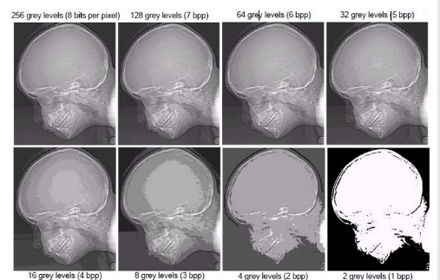value of each sample is rounded off to the nearest integer (quantization).
  + **error increases** as the number of quantization bits used to represent the pixel samples decreases
  + **False contouring effect** is quite visible in images displayed using 16 or less gray levels.
  + 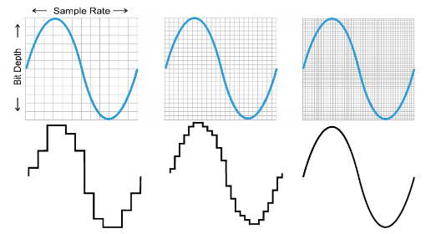**Bit depth (sample size):** The number of bits required to represent the value of each sample.
  + the quantized value will differ from the actual signal value, thus always introducing an error. => Rounding function
  + The **error decreases** as the number of bits used to represent the **sample increases => unavoidable and irreversible loss.**
  + 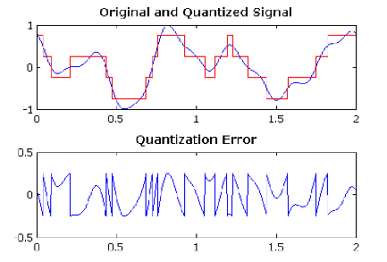how many bits should be used to represent each sample? Is this number the same for all signals?
    - depends on the type of signal and what its intended use is.
    - **Audio signals**, which represent music, must be quantized on **16 bits** . Musical instruments
    - **Speech** only requires **8 bits**. Just Human Voice
  + **uniform quantization: intervals** in which the **output range** of the signal is **divided into fixed** and **uniformly separated intervals** depending on the **number of bits** used.=> بيتقطع المحور الى مقاطع متساوية
  + **Nonuniform quantization schemes:** the distribution of all output values is **nonuniform**.
    - it is more correct to distribute the quantization intervals nonuniformly.
    - 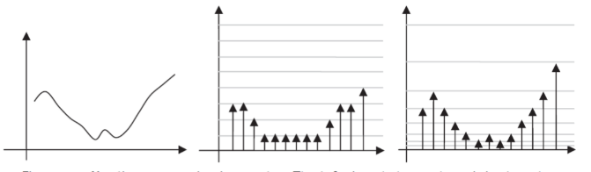Because the distribution of output values in such signals **is not uniform** over the entire **dynamic range.**
    - **quantization errors** should also be distributed nonuniformly**.**
  + **Bit rate** describes the number of bits being produced per second
    - critical **importance** when it comes to **storing a digital signal**, or **transmitting it across networks**
    - Bit Rate = $\frac{Bits}{Second}= \frac{Sample produced}{second}=\frac{Bits}{Sample}=Sample rate*Quantization bits per sample$
    - the bit rate should be just **right to capture** or convey the necessary information with **minimal perceptual distortion**, while also **minimizing storage requirements**

## Sampling theorem and aliasing

* The **rate** at which sampling **should occur**.
* The value of a **nonstatic** signal keeps changing depending on its frequency content.=> Captured not like Sinusoidal waves
* Theoretically => Nyquist Theory
  + if a signal is sampled at **more than twice** its **highest frequency** component, then it can be **reconstructed** exactly from its samples.
  + if it is sampled at less than that frequency (called **undersampling**), then **aliasing will result**.
  + **Aliasing** is the term used to describe loss of information during digitization.
  + This causes **frequencies to appear** in the sampled signal that **were not** in the original signal.
  + we must use a sampling rate equal to at least **twice the maximum frequency** content in the signal. This rate is called **the Nyquist rate**.
* 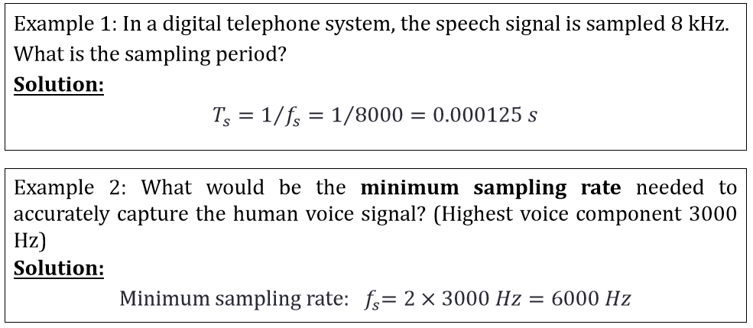

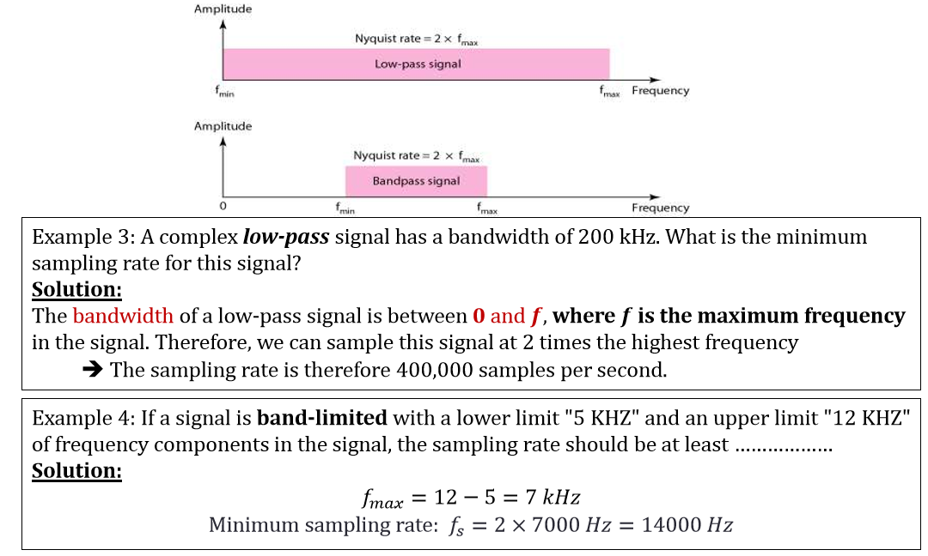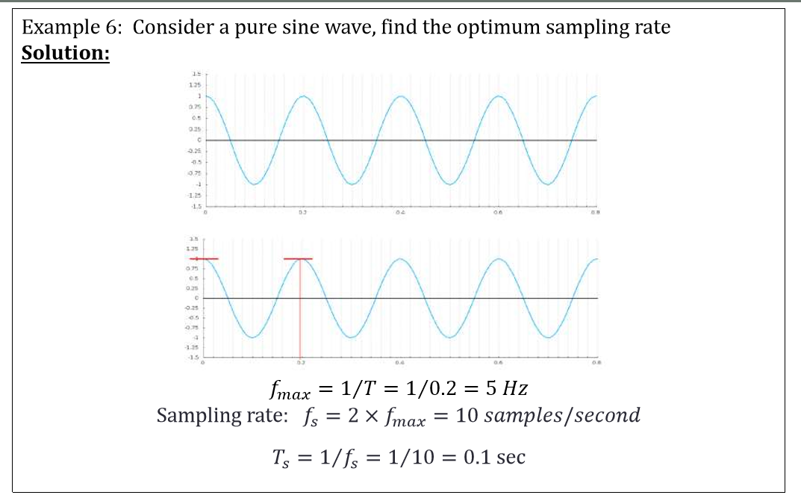

## Aliasing in Spatial Domains

* Aliasing effects in the spatial domain are seen in **all dimensions**.
* 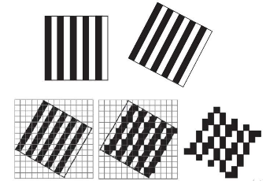fewer samples display increased effects of **blur**
* example of aliasing, called the **moiré effectis** a pattern in the image being photographed, and the **sampling rate** for the digital image is **not high enough** to capture the **frequency of the pattern.**

## Filtering

* ( a signal processing function) filter is to => remove unwanted parts of the signal
  + Removing random noise and undesired frequencies, and to extract useful parts of the signal
* There are two main kinds of filters: **analog and digital**.
  + 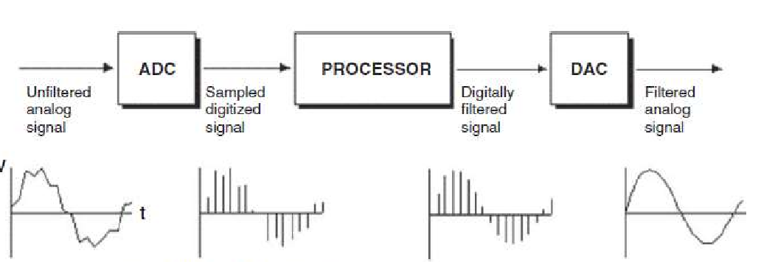**analog filter** uses **analog electronic circuits** made up from components such as resistors, capacitors, and operational amplifiers (op-amps) to produce the required filtering effect. => using circuits like noise reduction
  + **digital filter**, on the other hand, uses digital numerical computations on sampled, quantized values of the signal. => using of a pc or digital signal processor (DSP) chip.
* There are 2 type of frequency component in the signal:
  + **High frequency component** are characterized by large changes in values over small distance.
    - ▪ Example: noise and edge
  + **Low frequency component** are characterized by little changes in values over small distance.
    - 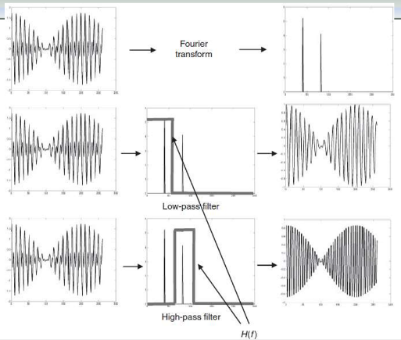▪ Example: backgrounds, skin texture
* 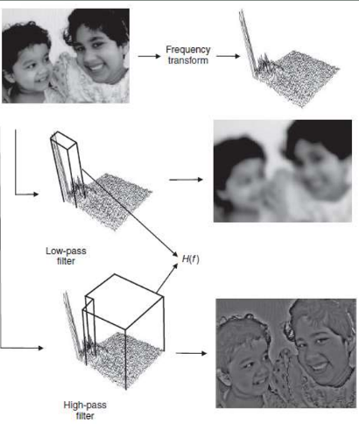 **Low-pass filters** remove high frequency content from the input signal. Such filters are used to avoid **aliasing artifacts** while sampling. Used for blurring and noise reduction.
* **High-pass filters**, remove the **low-frequency** content and are used to **enhance edges and sharpen an image**.
* **Band-pass filters** output signals **containing the frequencies belonging to a defined band.**

# Module 3 (Media Representation and Media Formats (Part 1))

## Digital Images

* 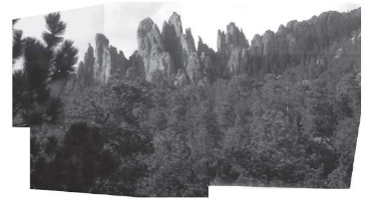Images are used in **various forms** for a **variety of applications**. (photographs, gray or color , used with text in documents , fax is another image representation used in communication.
* Images can be **combined** to create interesting applications involving **mosaics**, **panoramas**, and **stereo imagery**.
* images form is the basic elements of video. => large mosaic created by combining different images.
* An image may be defined as a **two dimensional** function f (x, y), where 𝑥, 𝑦: the spatial coordinate, 𝑓 the amplitude of any pair of coordinate 𝑥, 𝑦 is called the intensity or gray level of the image at that point.
* 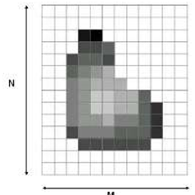Digital Image: 𝑥, 𝑦 and 𝑓 are all **finite (discrete quantities).**
* Digital image is composed of matrix of (picture elements, image elements or **pixels).**
* **width** gives the number of pixels that span the image **horizontally** (M)
* **height** gives the number of pixels that span the image **vertically**(N)
* **pixel depth** is the number of bits per pixel (k) **=>** is the same for all pixels of a given image.
* Number of bits required to store a digitized image 𝑏 = 𝑀 ×𝑁 ×𝑘
* The Pixel Depth depends on the color space representation (gray or color) and is typically segregated into channels.
  + 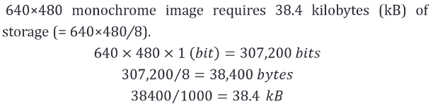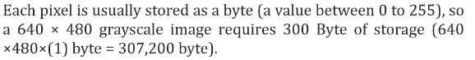grayscale images (intensity image) => 8 bits => corresponds to **light intensity**
    - Each pixel has a gray-value between 0 and 255.
  + it is visualized as a shade of gray denoted Color => 24 bit RGB , 32 ARGP with transparency
  + Monochrome – Binary image 1 bit => satisfactory for pictures containing only **simple graphics and text**
    - Efficient in terms of storage Document processing, handwriting, fingerprint

## How to print multi-level images (8-bit) on 2-level (1-bit) printers

* 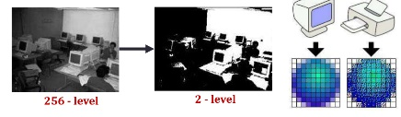**halftone images**: the number of **colors used is minimized** to lower printing costs.
  + creates ranges of grays or colors by using variable-sized dots.
  + Dithering is a Technique to achieve the half-tone printing
* 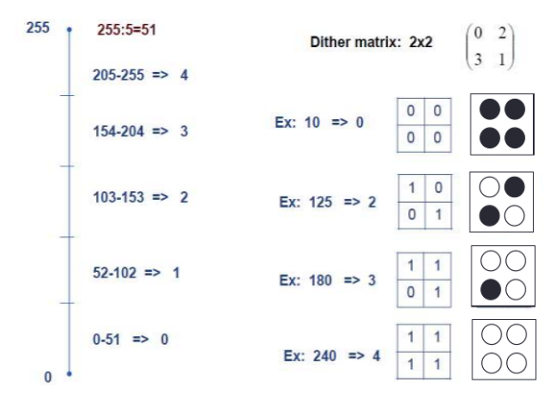**Dithering** For printing on a 1-bit printer, dithering is used to calculate larger patterns of dots
  + strategy is to replace a pixel value by a larger pattern
  + **Half-tone printing** is an analog process that uses smaller or larger filled circles of **black ink** to represent **shading**, for newspaper printing
  + If we use a 2 × 2 dither matrix, we can represent 𝑛2 +1 or 2𝑛 +1 levels of intensity resolution.
  + For example, if we use a 2 × 2 dither matrix $\left(\begin{matrix}0 & 2 \\ 3 & 1\end{matrix}\right)$
  + We can first re-map image values in 0..255 into the new range 0..4 by (integer) dividing by 256/5.
  + if the pixel value is 0 we print nothing, in a 2 × 2 area of printer output. But if the pixel value is 4 we print all four dots.
  + The rule is: **If the intensity is > the dither matrix entry then print an on dot at that entry location: replace each pixel by an n × n matrix of dots.**

that the image size may be **much larger**, for a dithered image, since replacing each pixel by a 4 × 4 **array of dots**, makes an image **42 = 16** times as large. => exponential Increment

if we **increase** the number of effective **intensity levels** by increasing the **dither matrix** size, we also **increase** the **size** of output image.

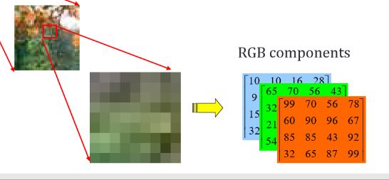

## 24-bit color image format

* each pixel contains **a vector** representing red, green and blue components.
* representing and storing graphical image information in RGB color space
* 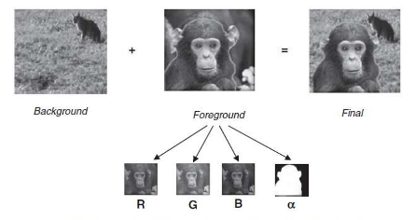28 * 28 * 28 =16,777,216 color Large space of colors
* 32bit images, with the **extra byte** of data for each pixel used to store an **alpha** => **transparency** (Shown in PNG file format, seems a monkey on a BG)

## 8-bit color image represent **Index Images**

* Each pixel contains **index number**=> pointing to a color in a color table. (8 bits/pixel)
* (so-called “256 colors”) in producing a screen image.
* use the concept of a **lookup table** to store color information.
* the image stores **not color**, each pixel contain index maps to a color
* 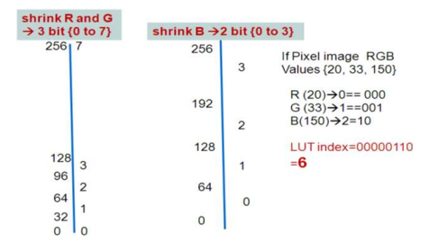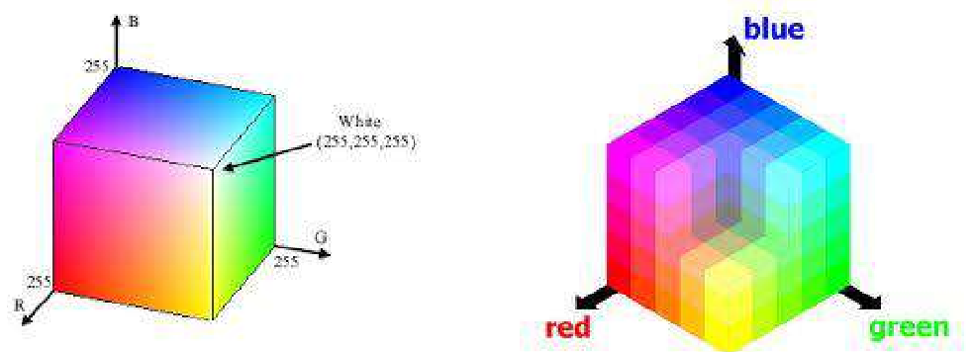Size of The actual color image = 3 Size of the indexed one
* Convert Color 24 bit image to 8-bit color image => LUT generation
  + divide the RGB cube into equal slices in each dimension.

## Color Models (RGB, CMY, HSV)

* most important **image characteristics** invariant to translation, *rotation*, and scaling.
* **Color model** is an orderly system for creating a whole ranges of color from a small set of primary color
  + abstract mathematical model describing the way colors can be represented as **tuples** of numbers

## **RGB** color model

* **commonly** used color systems, **+additive color model => additive primary colors, red, green and blue.**
* main purpose => representation and display of images **in electronic systems =>** televisions and computers and photography , PC monitors, cameras and scanners, **but it cannot be used for ~~print production.~~**
* 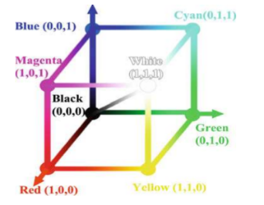It can be represented by the color cube
* gray level is defined by the line 𝑅 = 𝐺 = 𝐵
* The primary colors can be **added to produce** the **secondary colors**
  + **R+B = Magenta , G+B =Cyan , R+G = yellow**
* The **combination** of red, green, and blue at full intensities makes **white.**
* A size of an RGB digital image depends on how many bits **we use for quantization**.
* (0,0,0) represents **black** and (1,1,1) represents **white.**
* converting a color image to **a grayscale one**, the **luminescence** is calculated as the mean value of the RGB components.

## **CMY** color model

* **-subtractive** color model, used in **color printing** , because the **white** is obtained by the **absence** of colors.
  + **ما فيش حبر أبيض**
* 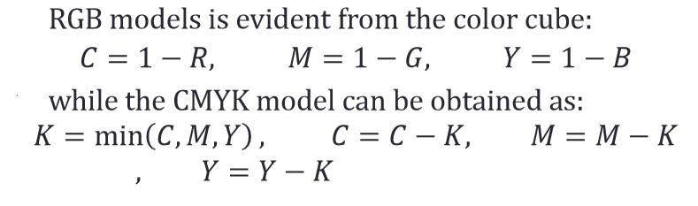**black** is obtained by **combining all three colors**, the printers usually have a **separate cartridge** for the black color.
* **CMY + Black = CMYK Model** K is used to refer to the black color.
* 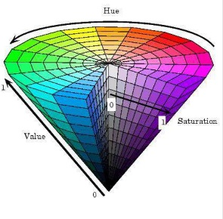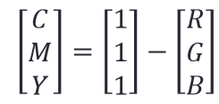 , 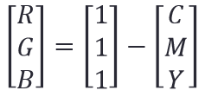

## **H**SV Color Model

* more oriented towards the **perceptual model.** طريقة رؤية الأنسان للطبيعة
* Hue (H), Saturation(S) and Value (V)
  + **H** is a measure of the **spectral composition of color** اللون نفسه
    - vary from red, through yellow, green, cyan, blue, and magenta, back to red.
  + **S** provides information about the purity of color, or more accurately, it indicates how far is the color from the gray level, under the same **amount of luminescence**. مقدار وضوح و نقاء اللون تدرجه من الرمادى للون كامل
    - the intensity of a hue **from gray tone (no saturation)** to pure **(high saturation).**
    - The value of S is the purity of the color => A value of 1 is pure => A val ue of 0 is grayscale
  +  **V** is a measure of **the relative luminescence.** شدة الاضاءة
    - maximum **brightness** value of its three color values
    - **Brightness** (Lightness) is the relative lightness or darkness of a particular color, from black (no brightness) to white (full brightness).
    - The value of V is the amount of **black** added to the color => A value of 1 means no black added => A value of 0 means the color will be black

## Aspect ratio

* Image aspect ratio refers to the **width/height** ratio of the images
  + 3:2 (when developing and printing photographs) 4:3 (television images) 16:9 (high-definition images) 47:20 (anamorphic formats used in cinemas)
* The ability to change image aspect ratios can change the perceived appearance of the **pixel sizes**
  + 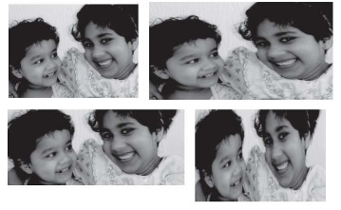known as the **pixel aspect ratio (PAR)** or sample aspect ratio (SAR).
    - A square pixel has a PAR of 1:1.
  + 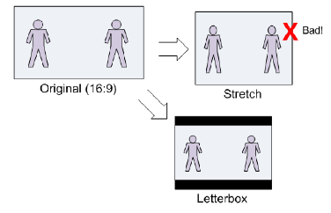If **the image aspect ratio** is **changed**, the **pixel aspect ratio** will need to **change** accordingly to accommodate the change in **area**, thus making the image **appear stretched** in one **direction**.
  + Means The Solution is A **Letter Box**

## Digital Image Formats

* Images can be **acquired by a variety of devices**. (captured by a digital camera or a scanner, created by Adobe Photoshop)
* Standard formats are needed to **store and exchange =>** viewing, printing, editing, or distribution
* many file types are used to **encode digital images, and compression**
* larger file types mean **more disk usage** and **slower downloads**. => Compression cutting the size of the file.
* images differ in the number of colors ,Like fewer image colors formats. this image formats designed **for exploit colors** => GIF
* 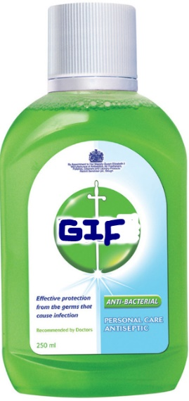GIF
  + **Graphics Interchange Format**, is the first graphic file type recognized by **early web browsers**.
  + 8-bit (256) color images only => suited for images **with few distinctive colors** (e.g., graphics or drawing).
  + employ a technique called **indexed color** => to reduce number of bytes
  + GIF is most suitable for graphics, diagrams, cartoons and logos with relatively few colors.
  + GIF is still the chosen format for **animation effects.**
  + Compared to JPEG, it is **lossless** and thus **more effective** with compressing images with a single color
    - 256 color means lose up to 99.998% of its colors.
    - يقضى على 99.998 من الألوان أفضل من ديتول فى القضاء على البكتريا
  + One edge of the GIF image format is the interlacing feature, giving **the illusion of fast** loading graphics blurry and fuzzy .بتلاقى الصورة شبحنت و انت نتك ضعيف يا عينى
  + Pros of GIF:
    - Can support **transparency**
    - Can do small **animation effects**
    - “Lossless” quality–they contain the same amount of quality as the original, except of course it now only has 256 color
  + Cons of GIF:
    - Only supports 256 colors
    - File size is larger than PNG
  + GIF actually comes in two versions:
    - GIF87a: The original specification
    - GIF89a: The later version. Supports simple animation via a Graphics Control Extension block in the data, provides simple control over delay time, a transparency index, etc.
* JPEG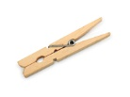
  + **JPEG (Joint Photographic Expert Group)** created by a working group of the **International Organization for Standardization (ISO).**
  + JPEG is the most important current standard for image compression
    - JPEG takes advantage **of human vision system has some specific limitations** in frequencies observation to achieve high rates of compression.
  + very **‘lossy’**, meaning so much information is lost from the original image
  + JPEG is very web friendly because the file is smaller
  + 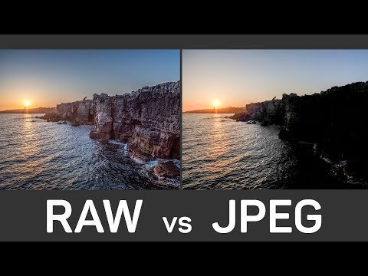Pros of JPEG:
    - 24-bit color, with up to 16 million colors
    - Most used and most widely accepted image format
    - Compatible in most OS (Mac, PC, Linux)
  + Cons of JPEG:
    - They tend to discard a lot of data
    - After compression, JPEG tends to create artifacts
    - Cannot be animated
    - Does not support transparency
* PNG
  + Portable Network Graphics, is a recently introduced format
  + It is an image format **specifically designed for the web**. **superior** version of the GIF
  + PNG is saved with **256 colors** maximum saves the color information more efficiently. It also supports an **8 bit transparency.**
  + Pros of PNG:
    - Lossless, so it does **not lose quality** and detail **after image compression**
    - PNG often **creates smaller file sizes than GIF**
    - Supports **transparency** better than GIF
  + Cons of PNG:
    - Not good for **~~large images~~** because they tend to generate a very large file, sometimes creating larger files than JPEG.
    - Unlike GIF however, it **~~cannot be animated.~~**
    - Not all web browsers can support PNG.
* TIFF
  + TIFF (Tagged Image File Format) format was developed by the Aldus Corporation supported by Microsoft الشركة دى بالنسبة ليه زى الأهلى لما تكون أهلاوى ~~و زى الزمالك لو كنت زملكاوى~~
  + recommended especially for **text and black and white images**
  + not widely supported by web browsers, it remains the standard format for printing, scanned documents and **Optical Character Recognition**.
  + TIFF is not compatible for all systems. TIFF is very flexible; it can be **lossy or lossless**
  + Pros of TIFF:
    - Very flexible format, it supports several types of compression like JPEG, LZW, ZIP or no compression at all.
    - High quality image format, all color and data information are stored
  + Cons of TIFF:
    - Very large file size
    - long transfer time, huge disk space consumption, and slow loading time.
* Windows BMP يا عينى عليك يا ويندوز 7 فكرتنى بالغالى
  + Windows Bitmap (BMP) specific to the Windows operating system and compatible in all Windows OS and programs (platform dependent).
  + **large and uncompressed**, but the images are **rich in color**, **high in quality**
  + Might an 8-bit, 16-bit or 24-bit
  + Disadvantages of BMP:
    - Does not compress well.
    - Very huge image files making it not web friendly.
    - No real advantage over other image formats
  + Many sub-variants within the BMP standard, PAINT and PICT
  + **PAINT** was originally used in the **Mac Paint program**, initially only for **1-bit monochrome** images.
  + **PICT** format is used in **MacDraw** (a **vector-based** drawing program) for storing structured graphics
* EXIF
  + EXIF (Exchange Image File) is an image format for **digital cameras => use the baseline JPEG format**
  + A variety of tags (many more than in TIFF) facilitate **higher quality printing**, includes specification of file format for **audio**
* **Print graphics**: TIFF is the best and only choice to support CMYK and YcbCr.
* **Web graphics** => **PNG, JPEG and GIF** are the most web friendly , **JPEG is great in small size** if you don’t mind quality , If you keep small size but retain **image quality use PNG**. **GIF is worst** choice , if you want to add **animation use GIF**.
* **Hardware compatibility**: Jpeg is the best , **Logos and line art and Clip Art=> JPEG is the worst choice , GIF is Good**

## Graphics

* Graphics objects can be represented as **vectors or rasters.**
* Vector graphics are geometric entities saved in a **vector format بتتحفظ على انها مجموعة من الارقام و المعادلات اللى بتمثل الاشكال الهندسية زىSVG** 
  + **+vector representations provide infinite resolution**
* Raster images are represented as **a grid of pixels**,

## Raster images

* (Bitmap images) are made up of a set grid of dots called pixels and **resolution dependent.**
* Raster file is **usually larger than a vector** graphics image file
* Raster file is usually difficult to modify without loss of information
* Raster image file types are :BMP, TIFF , GIF, and JPEG files
* There different sources of raster image( Photographs from digital cameras — Screenshots — Scanned images — Captured video frames are bitmaps)
* + **suitable for continuous tone pictures like photographs**
* **- shrink or stretch the pixels results in a significant loss of clarity and very blurry image.**
* **- size of a bitmap image is large. Computer has to store information about every single pixel in the image.**

## Vector images

* suitable for pictures **with areas of solid, clearly separated colors**— cartoon images, logos, and the like.
* drawn object by object in terms of each **object’s geometric shape.**
* Many file formats for vector graphic fh, .ai, .wmf, .eps,
* Sources of vector image: — Charts — Diagrams — Data visualizations.
* **+ suitable for pictures that have solid colors and well‐defined edges and shapes**
* **+ does not take up so much space (small size).**
* 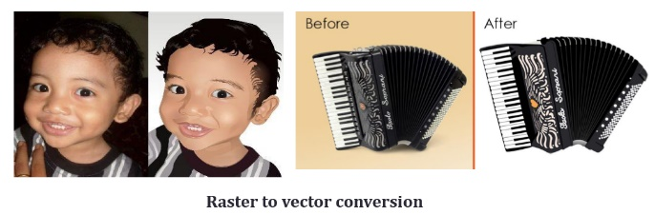**+ contain data about the points, mathematical formulas, lines and curves which form the object.**
* **+ Easily converted to bitmapped.**
* **+ Can be scaled (resized) keeping original quality and file size.**
* **- Only individual objects can be edited not pixel by pixel.**
* **- Difficult to recreate realistic images.**

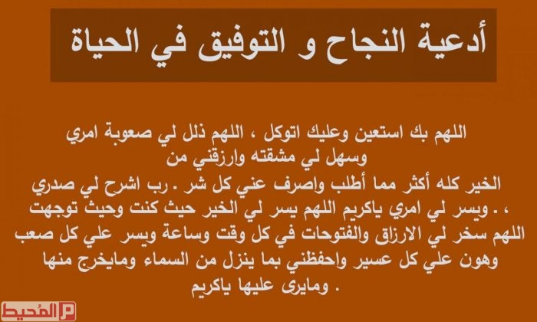

# Media Representation and Media Formats (Part 2 Videos)

## C:\Users\AhmedKhalil\AppData\Local\Microsoft\Windows\INetCache\Content.MSO\ED81F80F.tmpOverview

* 20th century, motion pictures stored on **film** have been **the vehicle** for much of our art
* Then **Analog video** stored on tapes, producing a revolution by giving the **public direct access** to the movies
* **Digital video** is further altering the field **visual quality, distribution, and interaction.**

## Representation of digital videos

* Video is a medium of communication that **delivers more information per second than any medium**
* **integrated Multimedia** because it **contains all the components of multimedia.**
* sequence of **discrete images** shown in **quick succession**.
* Each **image** in the video is called a **frame**
* **image attributes** **remain constant** for all the images in the length of the video. الخصائص ثابتة لكل صور الفيديو
* 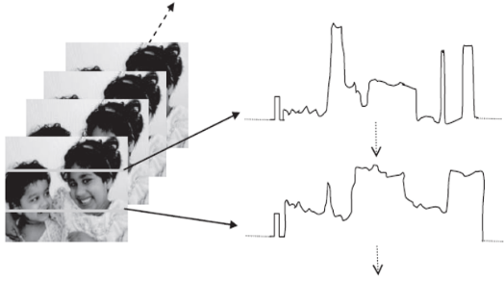**video** has the **same properties** such as width, height and aspect ratio.
* **Frame rate** is the rate at which the images are shown.
  + **Film** is displayed **at 24 frames** per second.
  + **Television standards** use 30 frames per second (**NTSC)** or 25 frames per second (PAL).
* 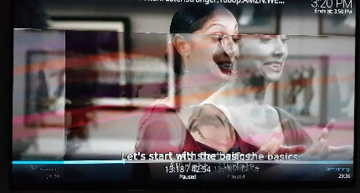If the frame rate is **too slow** , the human eye perceives an unevenness of motion called **flicker** .
* **Frame rate** must be **fast** enough for motion to appear **smooth**
* **Analog video** is converted to a **1 D** signal of scan lines.
* **Scanning formats :** 
  + **Progressive scanning**
  + **Interlaced scanning**

## Analog Video Scanning

* 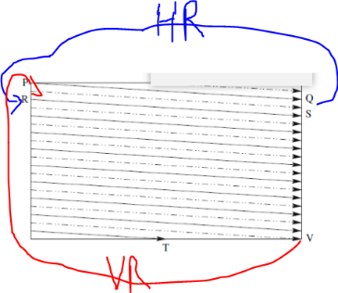process of breaking down the scene into **picture elements(Pixels) horizontally** and reassembling them on the screen

Interlaced Scanning:

* the whole screen is filled by the **two sets** of interlaced scanning lines => fields.
* **“odd” set first traced** and then **“even”** field—two fields make up one frame
* First the solid(odd) lines are traced—P to Q, then R to S, and soon, ending at T —then the even field starts at U and ends at V.
* **horizontal retrace** :**The jump from Q to R , Vertical Retrace : The jump from T to U or V to P.**
* the **resulting video** might be unacceptable and has occasional **flicker** and **artifacts**.

### Progressive Scanning

* 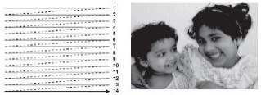Video is of better quality when it is captured and drawn **progressively**, which **eliminate**s the occasional **flicker**.
* scanning traces through a **complete picture (a frame**) row-wise foreach time interval.
* Scans lines one at a time from **left to right** then from one row to the next **(top to bottom)** **in chronological order**
* **Smoother, more detailed and clearer image Is obtained without any blurring.**
* Bandwidth requirement is **twice as compared** to interlaced video scanning.
* Maximum frame rate is30 frames/second

## صورة ذات صلةVideos color models (YUV , YIQ , YCbCr)

* The **YUV and YIQ** are standard color spaces used for **analog television transmission.**
  + **Y** is linked to the component of **luminance (brightness, or lightness)**
    - black and white TVs decode only the Y part of the signal.
  + 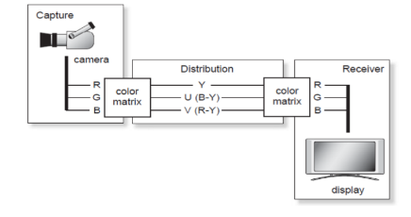**U and V or I and Q** are linked to the components of **chrominance**, which provide color information.
* **YCbCr** space is used in **digital video** using **Jpeg and Mpeg Compression** Techniques
* **video camera** converts the **RGB data** captured by its sensors into either analog signals (YUV-YIQ) or digital signals (YCbCr).
* 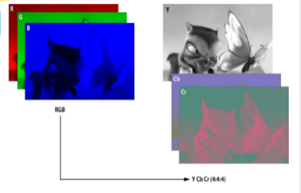these **color spaces** must be **converted** back again to **RGB** by the **TV or display system**.
* **primary advantage** of **luma**/**chroma** systems such as **YUV, and its relatives YIQ**, compatible with **black and white** analog television. **old monochrome displays**. — The **U and V** are simply discarded.
* If **displaying color**, all **three channels** are used
* The YUV space has a very **practical bandwidth-saving usage.**
* **humans** are **not as susceptible** to changes in **chrominance** as they are to **luminance**.
  + it might be **worth transmitting** less color information than **luminance** information.
  + **humans** are less tolerant to **chrominance**
* YUV allows the representation of a color in terms of its **luminance** and **chrominance** **separately**
  + allowing the **chrominance** information to be **subsampled**

## YUV color model

* **analog video model** => YUV: **Black-and-White component (Y)** and **color information (U and V)**
* 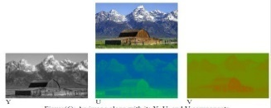**YUV** is **~~not compressed RGB~~** but are the **mathematical equivalent of RGB**. To convert The RGB model to YUV:
  + 𝒀 = 𝟎.𝟐𝟗𝟗𝑹 + 𝟎.𝟓𝟖𝟕𝑮 + 𝟎.𝟏𝟏𝟒𝑩 القوانين للفيديو مودل مش للحفظ
  + 𝑼 = 𝑩 –𝒀
  + 𝑽 = 𝑹–𝒀
* 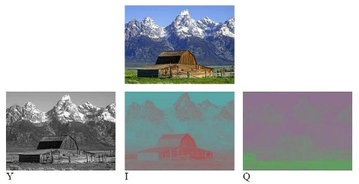**Eye** is most **sensitive to Y**. Therefore any error in the **luminance** (Y) is more important than the **chrominance** (U, V) values.

## Conversion to YUV

* Video frames are normal images (RGB)
* RGB color space is used by **cathode-ray tube–based CRT** display devices
* For **transmission purposes** the RGB signal is transformed into a YUV signal.
* YUV decouple the **intensity information** (Y or **luminance**) from the color information (UV or **chrominance**).
  + **separation** was intended to **reduce the transmission bandwidth**,=> human sensitivity for luminance
  + **reducing** the **color resolution** does **not affect our perception**. لو نقصت من حجم الألوان غير ملاحظ بالنسبة للانسان

## YIQ color model

* YIQ used in color **TV broadcasting** (**Analog video model**)
* I and Q give the **chromaticity** information
  + **I** contains **orange**-**cyan** color information
  + **Q** contains **green**-**magenta** color information
* **Y** is stored with **higher precision** than **I and Q =>** we can detect slight changes in **brightness** more easily than slight changes in **hue**
* Human eyes are most sensitive To **Y > I > Q =>** less **bandwidth** is required for Q than for I
* Y = the same of YUV , 𝑰 = 𝟎.𝟔𝑹 –𝟎.𝟐𝟖𝑮 −𝟎.𝟑𝟐𝑩 𝑸 = 𝟎.𝟐𝟏𝑹–𝟎.𝟓𝟐𝑮 + 𝟎.𝟑𝟏𝑩

## YCbCr color model

* Uses in **digital video model**. **Y′ is** the **Luma** component and **Cb and Cr** are the **Blue-difference** and **Red difference** Chroma components. => **Closely related** to **YUV**
* 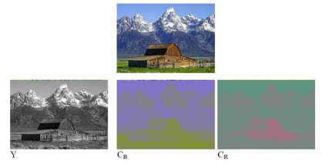𝑪𝒃 = ((𝑩 –𝒀)/𝟐) + 𝟎.𝟓 𝑪𝒓 = ((𝑹–𝒀)/𝟏.𝟔) + 𝟎.𝟓

## Analog Video and Television

* **Video signals** have been traditionally **transmitted as analog** signals for television **broadcast**.
* The analog video signal is scanned as a **one-dimensional signal** in time, captures the time varying image **intensity information**
* 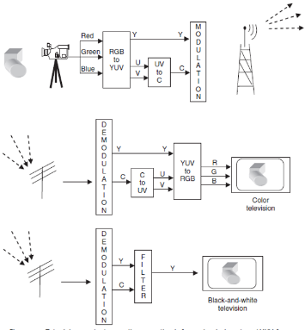**broadcast** of analog video for television **requirements** ( **YUV color space conversion** , **interlaced scanning**) => **not necessary** for **digital video** representation

## Digital Video

* Must converting from **analog to digital** before **Transmitting, Storing , processing**
* Digital video comprises a **series digital images** displayed **in rapid succession**.
* Digital video can be copied with **no degradation in quality=> unlike Analog**
* stored on **hard disks** or **streamed over the Internet** to end users can also includes a digital **audio sound track**
* **integrated** to various multimedia applications
* **Direct access** is possible, which makes **nonlinear video editing** achievable as a simple
* **Ease of encryption** and better tolerance to channel noise

## Chroma Subsampling

* there is always a **desire to reduce (compress)the signal**.=> storage and transmission requirements
* video system **can be optimized** by devoting more bandwidth **to the luma** component (Y) than to the **color** difference components Cb and Cr
* 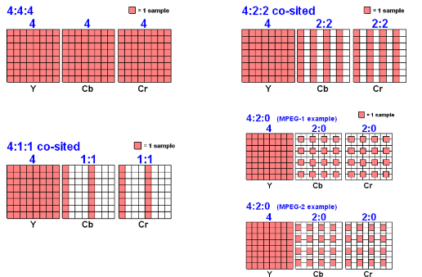**Chroma subsampling** is the **reduction** of color **resolution =>** The color components are compressed by sampling them at a lower rate than the brightness.
* how many pixel values, per **four original** pixels ,are actually sent:
  + 4:4:4 means **no subsampling the original** , 4:2:2 **horizontal subsampling** of the Cb, Cr signals by a factor of 2
  + "4:1:1" subsamples horizontally by a factor of 4 , "4:2:0" subsamples in both the horizontal and vertical dimensions by a factor of 2.

## Bitrate and video size

* how much data is transmitted in a given amount of time. bps bits per second
* The bitrate of video track is video bitrate — The bitrate of audio track is audio bitrate
* determines the **size and quality** of video and audio files
  + **higher bit rate** will accommodate **higher image quality** but **large file size**
* **Bitrate** (BR) measured the rate at which frames are displayed in **frames per second(FPS).**
* 𝐵𝑖𝑡𝑟𝑎𝑡𝑒 𝐵𝑅 = 𝑤𝑖𝑑𝑡ℎ 𝑊 ×𝐻𝑖𝑔ℎ𝑡 𝐻 ×𝐶𝑜𝑙𝑜𝑟𝑑𝑒𝑝𝑡ℎ×𝑓𝑝𝑠 قانون مهم
* 𝑉𝑖𝑑𝑒𝑜𝑠𝑖𝑧𝑒 = 𝑤𝑖𝑑𝑡ℎ 𝑊 ×𝐻𝑖𝑔ℎ𝑡 𝐻 ×𝐶𝑜𝑙𝑜𝑟𝑑𝑒𝑝𝑡ℎ×𝑓𝑝𝑠 ×𝑑𝑢𝑟𝑎𝑡𝑖𝑜𝑛 قانون مهم
* 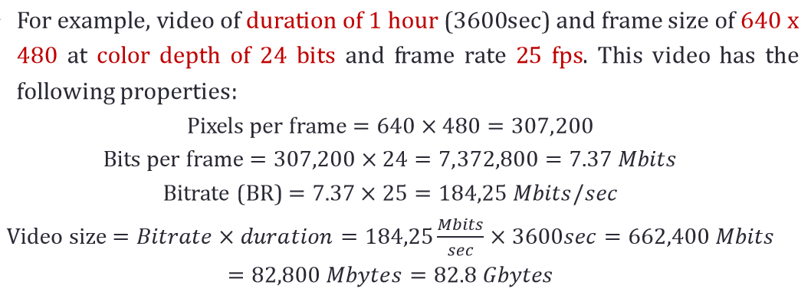The file is so large to transmit
* One the most used method for video signal reduction is **chroma subsampling.**

## How chroma subsampling affect file size and bit rate with examples?

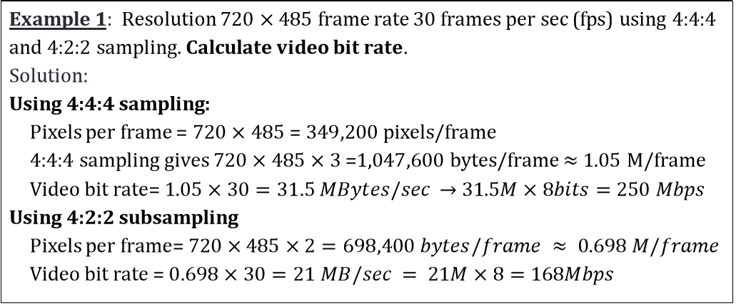 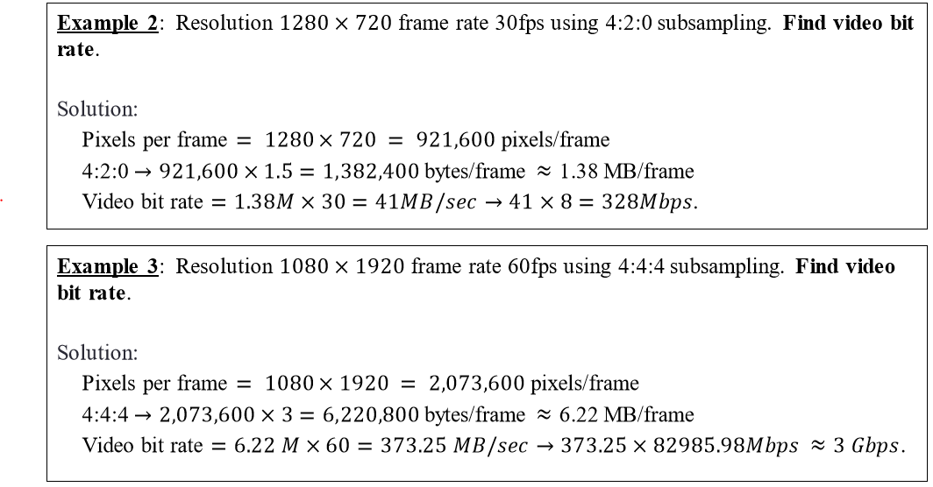

## Analog Video Formats

* three sets of standards for analog broadcast video
  + NTSC (National Television Standards Committee)
  + PAL Video (Phase altering line)
  + SECAM Video (sequential color avec memoire)
* used for defining a method for **encoding video** information **into electronic signal** that creates a television picture.
* Each has its **standard** and are **not compatible** with each other.

### NTSC video

* mostly used in **North America** and **Japan**. It uses the **familiar 4:3 aspect ratio , 525 scanlines per frame, 30 frames per second(fps).**
* follows the **interlaced scanning system**, and each frame is divided into **two fields**, with **262.5** lines/field.
* Used YIQ color model

### PAL video

* used in **Western Europe**, **China**, **India**, and many other parts of the world.
* uses **625 scan lines per frame**, **at 25 frames/second**, with **a 4:3 aspect ratio** and **interlaced fields**
* PAL uses the YUV color model
* 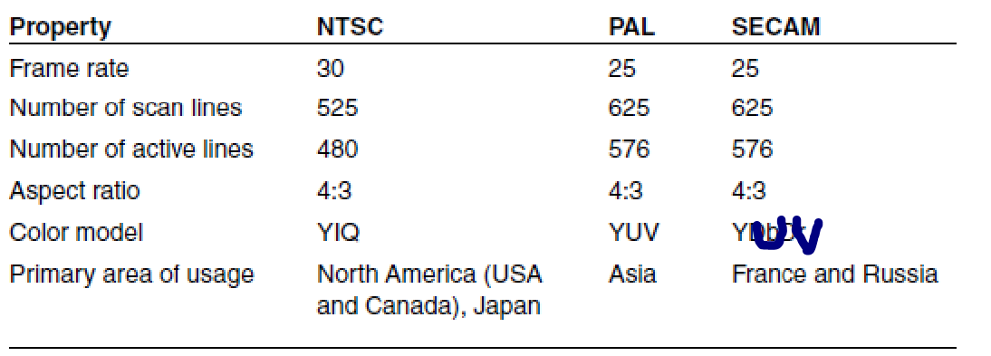Chroma signals have **alternate signs (e.g., +U and -U)** in successive scan lines, hence the name “Phase Alternating Line” improving quality.

### SECAM video

* uses **625 scan lines per frame**, at **25 frames per second**, with a **4:3 aspect ratio and interlaced fields**.
* SECAM and PAL are very **similar**.
* In **NTSC and PAL** both U or I and V or Q are **broadcast concurrently**
* In **SECAM**, U and V are **sent alternately**.

## Digital Video Formats

* **CCIR (Consultative Committee for International Radio)** body has established the **ITUR_601** standard that has been adopted by the popular DV video applications.
* **CIF format (Common Interchange Format)** was established for a **progressive digital broadcast television**.
* **The Quarter Common Interchange Format (QCIF)** was established for **digital video conferencing** over ISDN lines
* **HDTV** supports a higher resolution display format along with surround sound. Standards are
  + 720p—1280 720 pixels progressive
  + 1080i—1920 1080 pixels interlaced , 1080p—1920 1080pixels progressive

## Video display interface

* Interfaces for video signal transmission from **some output devices** (e.g., set-top box, video player, video card, and etc.) to a **video display** (e.g., TV, monitor, projector, etc.). من الأخر كابلات الشاشات

### Analog display interface

* Analog video signals are often transmitted in one of **three different** interfaces:
* 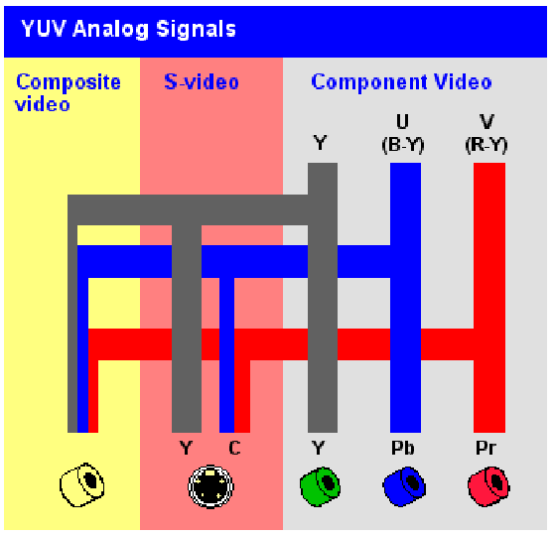**Component video**: three separate video signals for the red, green, and blue image planes
  + 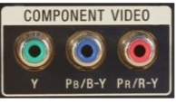.Each color channel is sent as a separate video signal.
  + Most computer systems use **Component Video**.
  + **best color reproduction** since there **is no "crosstalk"** between the three channels.
  + **requires more bandwidth** and **good synchronization** of the three components.
* **Composite video :** color ("chrominance") and intensity ("luminance") signals are mixed into a **single carrier wave.**
  + Since color and intensity are wrapped into the same signal, some interference between the luminance and **chrominance** signals is inevitable**.**
* **S-video**: uses **two wires**, one for **luminance** and another for a composite **chrominance** signal.
  + **less crosstalk** between the color information and the crucial gray-scale information.

### Digital display interface

* widely used digital video interfaces include
  + Digital Visual Interface (DVI) : developed by the **Digital Display Working Group (DDWG)** for transferring digital video signals, particularly from a **computer’s video card** to a **monitor** .
    - 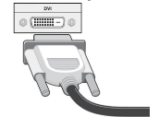It carries **uncompressed digital video** , multi Modes (analog only => DVI-A and digital only =>DVI-D , DVI-I(digital and analog).)
    - **DVI compatible with VGA** (though an adapter is needed between the two interfaces).
  + High-Definition Multimedia Interface (HDMI) : newer digital audio/video interface developed to be **backward-compatible with DVI.**
    - HDMI **does not carry analog signal** and hence **is not compatible** with VGA.
    - **DVI is limited to the RGB color range** (0–255).
    - HDMI supports both RGB and YCbCr 4:4:4 or 4:2:2., supports digital audio

#### DisplayPort : developed by VESA,

* + - uses packetized data transmission, like the Internet or Ethernet.
    - small data packets known as micro packets. achieve a higher resolution yet with fewer pins than the previous technologies.

# Media Representation and Media Formats (Part 3 Sound)

* Physics describes sound as a **form of energy** that is transmitted through a medium as **pressure waves**. captured by an **electromechanical device like magnetic tape.**  التضاغطات و التخلخلات بتاعت الأمواج الميكانيكية 1 اعدادى
* 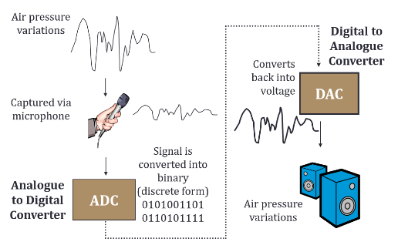To get the **digital version** => **Digitization representation Process**
* 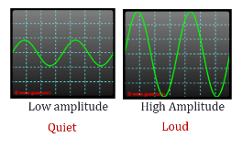Any signal can be characterized by **Amplitude, Frequency**, and **Phase** (period).
* **Amplitude (A)** is the **magnitude**(displacement) of the signal at a given instant in time(t).
  + **High volume** implies **high amplitude** and vice versa
* **Period(T):**is the time a wave requires to **complete a single cycle** Measured in seconds(s)
* **Frequency(f)** is the **number of cycles a wave** completes in one second(s) Measured in hertz(Hz) **f = 1/T**
* **The pitch of a sound** => The **more frequent vibration** occurs the **higher the pitch** of the sound.
* **Signal > 20 KHZ : Ultrasonic , Signal < 20 Hz : Infrasonic --- Sound signals between them**
* **Analog Sound Recording** refers to audio recorded using methods that **replicate** **the original soundwaves** (Vinyl records and cassette tapes)
* **Digital audio** is recorded by **taking samples** of the original sound wave at a specified rate.( CDs and Mp3 files)
* **Analog** sound wave **replicates** the original sound , and **Digital** **Replicates the sampled** section of the wave.
* The potential **fidelity of an analog recording** depends on (**the sensitivity of the equipment, medium used to record** and playback the recording)
* **Digital** audio fidelity depends on the (**rate at which the recording equipment sampled** the original sound wave)
* **Analog** audio can be **simple or complex**. **Simple sinusoidal** wave corresponds to a **pure tone,**
* **complex** wave consists of **multiple frequencies** or sinusoidal waves **combined together.**

## Representation of digital Audio

* **Digitizing** an analog audio signal requires **sampling and quantization.**
* **process of conversion: pulse code modulation (PCM). Consist of (Sampling , Quantization , Binary encoding)**

## Sampling

* 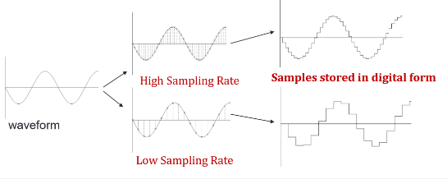**Quality of digital recording** depends on the **sampling rate, Higher sampling means Higher Quality and Vise Versa.**
* **Nyquist sampling theorem** define the **Minimum Sampling Rate**.
* if a signal is sampled at **more than twice** its **highest frequency** component, then it can be reconstructed exactly from its samples.
* **Undersampling :** Signal sampled at **less than** that frequency => Aliasing Loss of Information
* 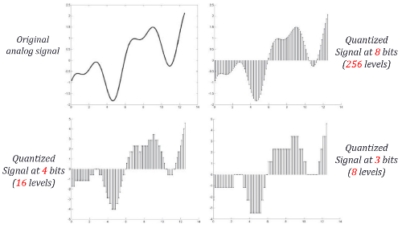**Oversampling:** higher sampling rate (**usually twice or more**) prevent aliasing.
* **𝑁𝑦𝑞𝑢𝑖𝑠𝑡 𝑟𝑎𝑡𝑒 = 𝑠𝑎𝑚𝑝𝑙𝑖𝑛𝑔 𝑟𝑎𝑡𝑒 (𝑓 𝑠) = 2𝑓𝑚𝑎𝑥 => correct sampling**

### Quantization

* **signal amplitude** at that position is **encoded** on a **fixed number of bits**.
* quantization of a sample value is **dependent on** the number of bits used to **represent the amplitude**.=> Bit Depth.
* The **greater** the **number of bits used**, the **better the resolution**, but the **more storage** space is required.
* The digital audio signal is finally rendered by converting it to the analog domain.
* another **characteristic commonly used to describe audio** signals is the number of channels **(Mono) one Channel ,(Stereo) 2 Channel , or multi-channel (Surround sound).**

## Signal-to-Noise Ratio (SNR)

* In any **analog system**, **random fluctuations** produce **noise** added to the signal => the measured voltage is thus incorrect.
* Is The ratio of **the power** of the **correct signal** to the **noise => (meaningful information) to (Unwanted Signal) (measure of the quality of the signal.)**
* measured in ***decibels (dB***), where 1 dB is a tenth of a **bel**. 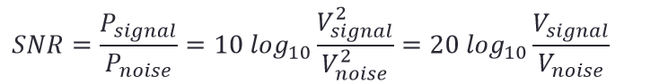
* 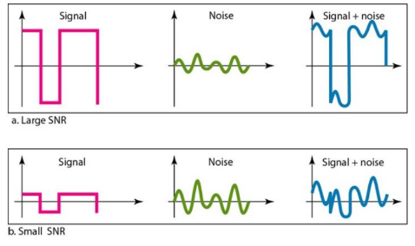The **power in a signal** is proportional to the **square of the voltage**. P α V2

### Signal-to-Quantization-Noise Ratio (SQNR)

* we must take into account the fact **that only quantized** values are stored.
* **precision** of each sample is determined by the **bit depth**, typically 8 or 16.
* There is also **an additional error** that results from **quantization**.
  + 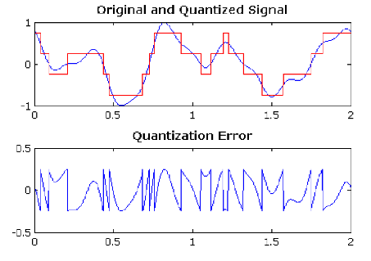we have only 8 bits in which to store values, then effectively we force all continuous values of voltage into only **256 different values.**
  + a **roundoff error**. It is not really **"noise"**. it is called **quantization** **noise** (or **quantization error**).
* (SQNR) characterized **quality of the quantization.**
* 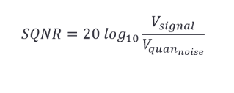**Quantization noise**: the difference between the **actual value of the analog** signal, and the **nearest quantization interval value**.
* At most, this error can be as much as half of the interval

## Audio file size’

* 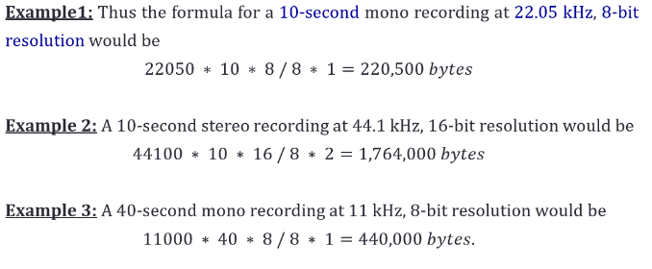**Stereo** recordings are made by recording **on two channels**, and are **life like** and **realistic**. **require twice the space of Mono**
  + sampling rate * duration of recording in seconds * (bit resolution / 8) * **2**
* **Mono** sounds are **less realistic**, flat, and not as dramatic, but they have as **smaller file size.**
  + Sampling rate *duration of recording in seconds* (bit resolution/8) * **1**
* **Audio resolution** (such as 8-or 16-bit) determines **the accuracy** with which a sound can be digitized.

## Commonly Used Audio Formats

* WAV sound file developed by **Microsoft** for use on ***windows based machines***.
  + the file format for standard music CDs.
  + uses **interesting algorithms** to compress raw sound without a loss in quality. **(Lossless compression)**
* AIFF : Developed by **Apple**, the “Audio Interchange File Format” is mostly used by ***Macintosh machines***.
  + AIFF files are easily converted to other file formats, but **can be quite large**.
  + One minute of 16-bit stereo audio sampled at 44.1kHz usually takes up about 10 megabytes.
  + AIFF is often used in high end applications **where storage space is not a consideration.**
* MP3 type of compression that can dramatically reduce file size without **drastically reducing sound quality**. (Lossy compression)
  + MP3 works by **chopping off** all sounds that are outside of the **normal human range of hearing.**
* RealAudio Developed by **Progressive Networks**, was the first format to allow for **real time streaming** of music and sound over the web.
  + Listeners are required to download the Real player to enjoy sound in RealAudio Format.
  + The Real player can also stream video and is currently in use **by millions of Internet users** worldwide.